**NATAS Wargame Walkthrough Report =>**

**Part 1: Natas0 to Natas17**

**Level: Natas0**

* **Step-by-Step:**
  + Open the URL in browser.
  + Notice username and password are given on the page.
* **Tools Used:**
  + Browser
* **Logic Behind the Solution:**
  + The first level is to teach you how to use HTTP basic authentication.

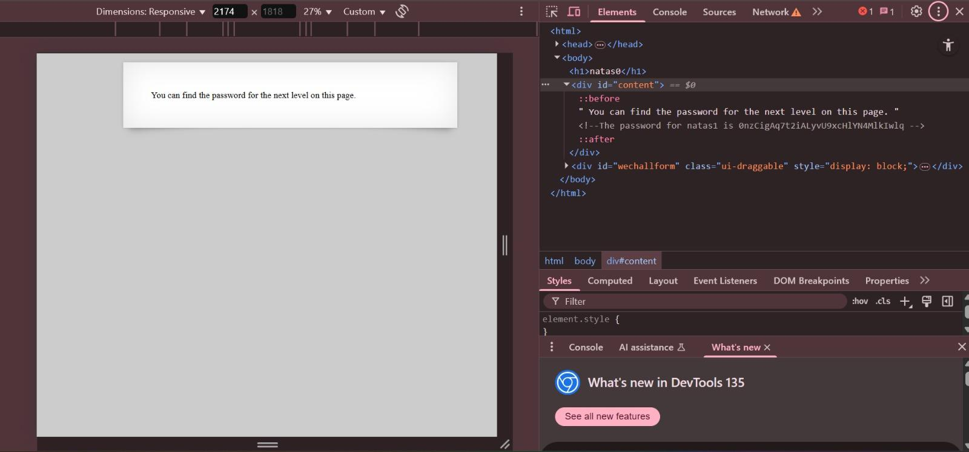

**Level: Natas1**

* **Step-by-Step:**
  + Open the URL in browser.
  + Right-click → View Page Source.
  + Find password hidden in a comment.
* **Tools Used:**
  + Browser
* **Logic Behind the Solution:**
  + Password hidden in HTML comments to teach checking page source.

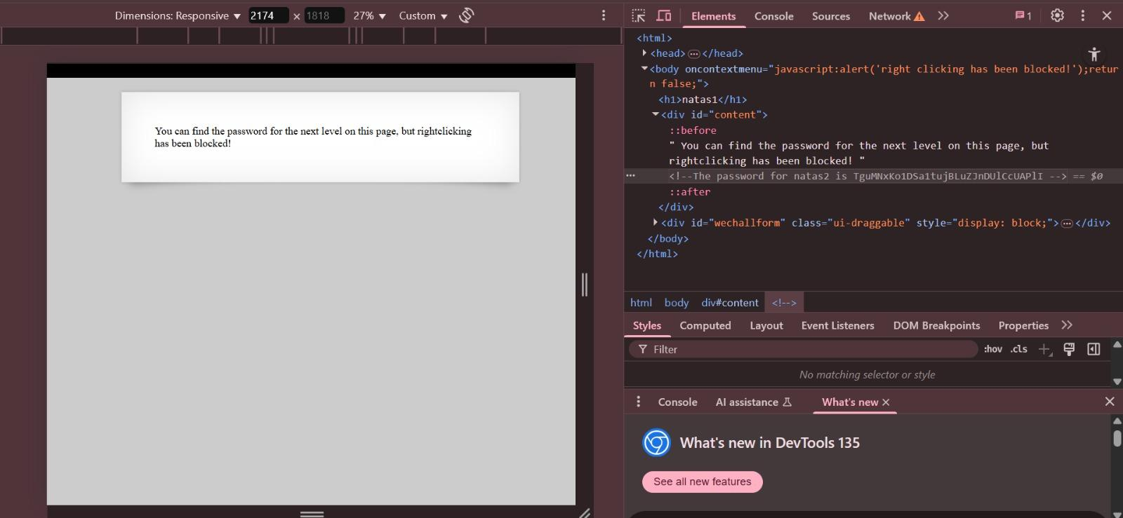

**Level: Natas2**

* **Step-by-Step:**
  + Open page and View Source.
  + Find a link to "/files/" directory.
  + Browse the directory and find the password file.
* **Tools Used:**
  + Browser
* **Logic Behind the Solution:**
  + Teaches exploring hidden directories.

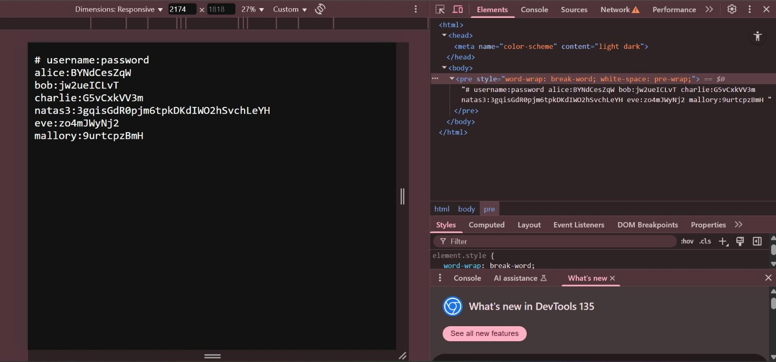

**Level: Natas3**

* **Step-by-Step:**
  + View Source.
  + Find hidden directory /s3cr3t/.
  + Find password inside it.
* **Tools Used:**
  + Browser
* **Logic Behind the Solution:**
  + Train users to look carefully into source code.

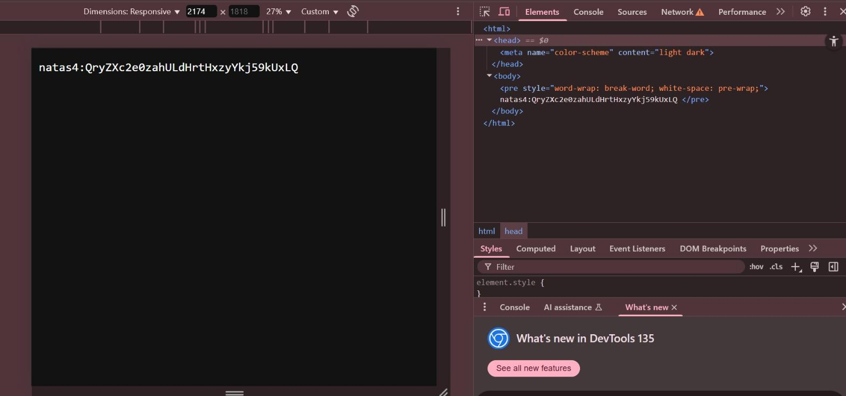

**Level: Natas4**

* **Step-by-Step:**
  + After accessing page, notice it redirects if 'Referer' is not set.
  + Manually set Referer header or use URL editing.
* **Tools Used:**
  + Browser
* **Logic Behind the Solution:**
  + Introduction to HTTP headers (Referer).

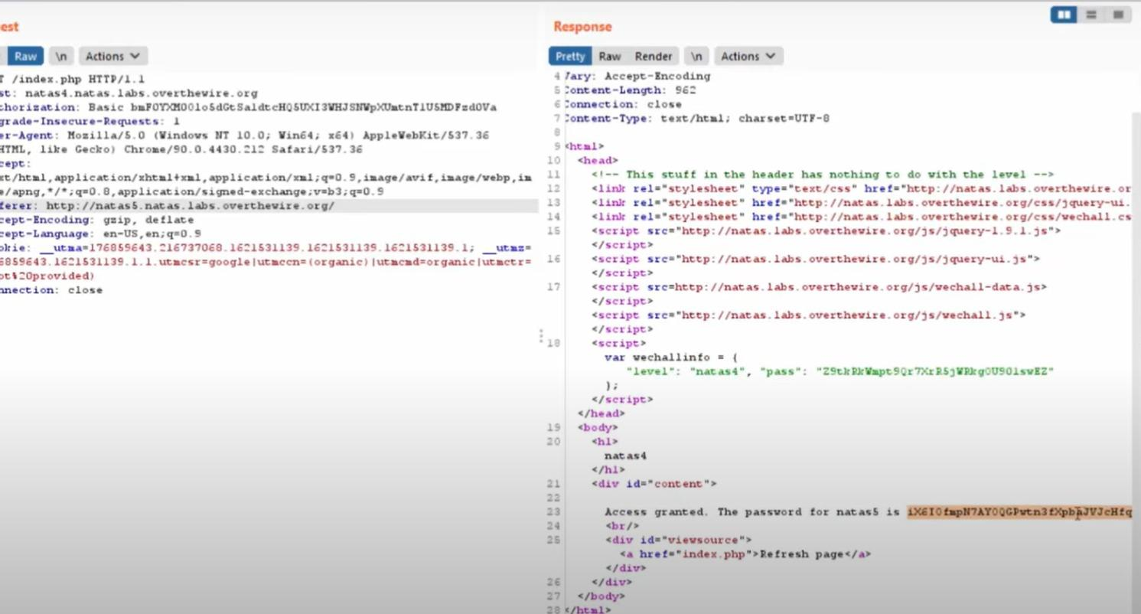

**Level: Natas5**

* **Step-by-Step:**
  + Inspect cookies.
  + Edit cookie 'loggedin' to 1.
* **Tools Used:**
  + Browser (Inspect Element)
* **Logic Behind the Solution:**
  + Teaches tampering with cookies.

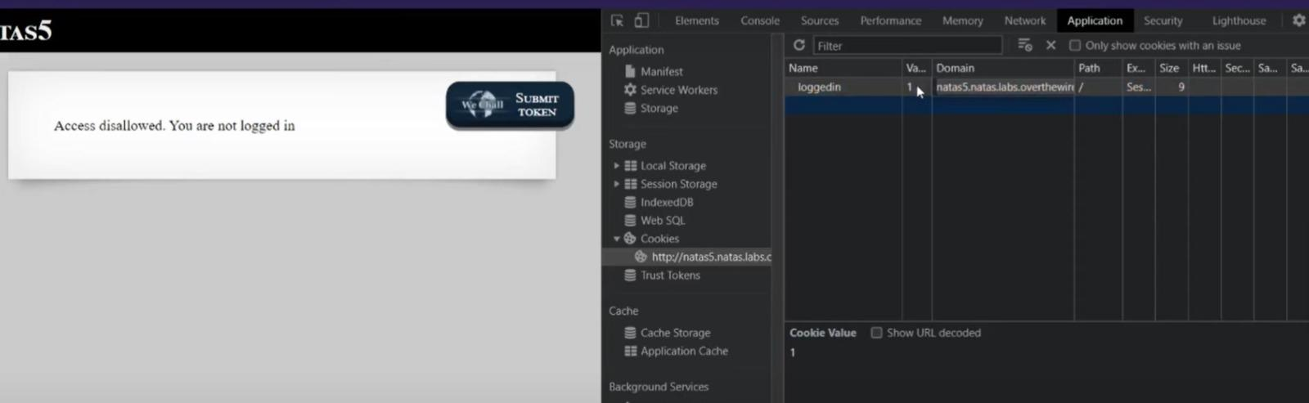

**Level: Natas6**

* **Step-by-Step:**
  + View Source.
  + Find encoded secret (Base64).
  + Decode using base64.
* **Tools Used:**
  + Terminal (echo + base64) or online tools
* **Logic Behind the Solution:**
  + Understand basic encoding techniques.

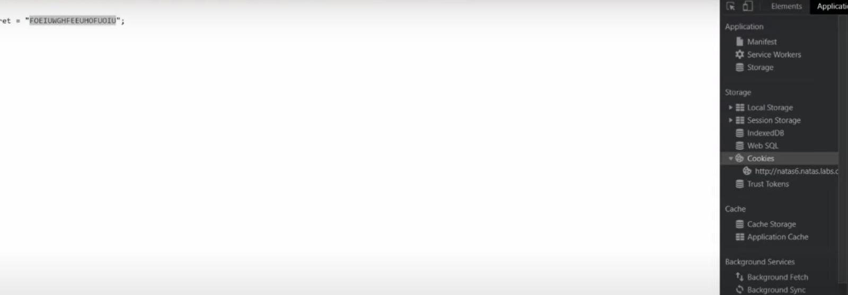

**Level: Natas7**

* **Step-by-Step:**
  + Modify URL parameter ?page=home.
  + Try Path Traversal with ?page=../../etc/natas_webpass/natas8.
* **Tools Used:**
  + Browser
* **Logic Behind the Solution:**
  + Introduces basic path traversal.



**Level: Natas8**

* **Step-by-Step:**
  + View Source.
  + Find custom hash function.
  + Reverse the logic with simple Python script.
* **Tools Used:**
  + Browser, Python
* **Logic Behind the Solution:**
  + Shows simple reversing of obfuscation.

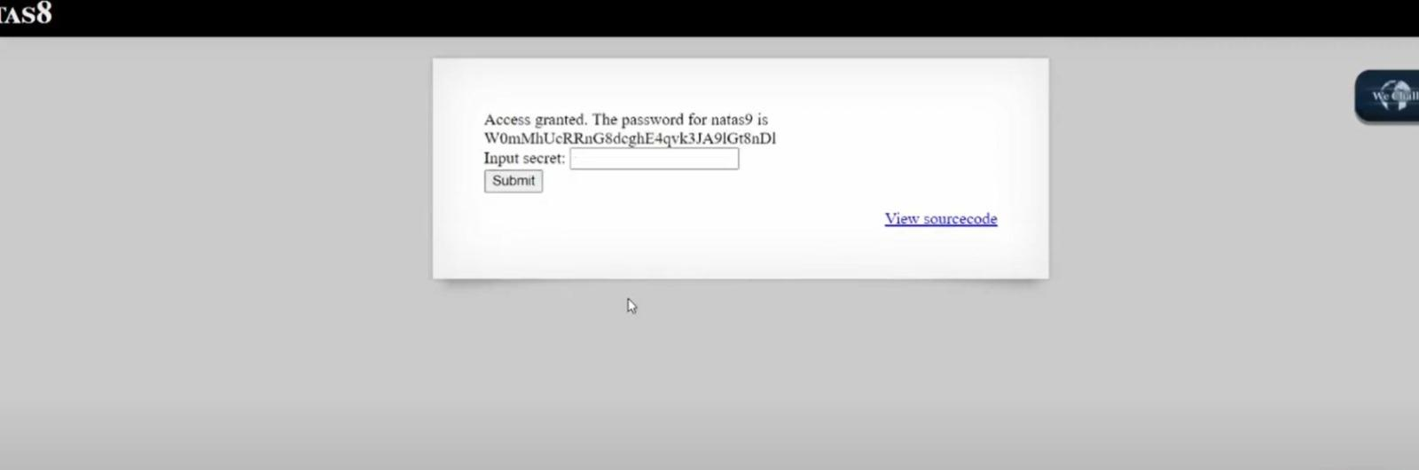

**Level: Natas9**

* **Step-by-Step:**
  + Input in search box: anytext; cat /etc/natas_webpass/natas10
* **Tools Used:**
  + Browser
* **Logic Behind the Solution:**
  + Introduces command injection.

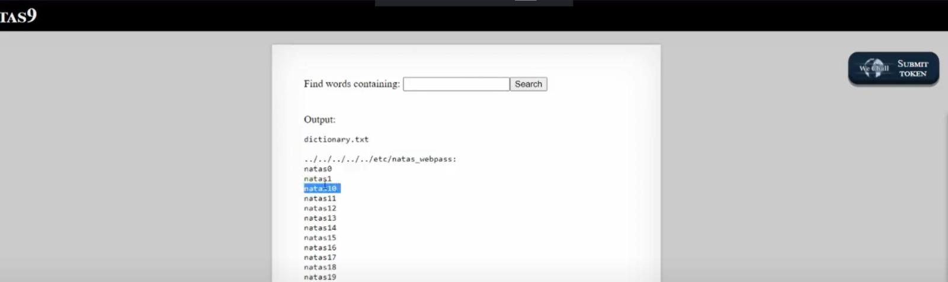

**Level: Natas10**

* **Step-by-Step:**
  + Input payload: anytext | cat /etc/natas_webpass/natas11
* **Tools Used:**
  + Browser
* **Logic Behind the Solution:**
  + Demonstrates using pipe | operator to inject commands.

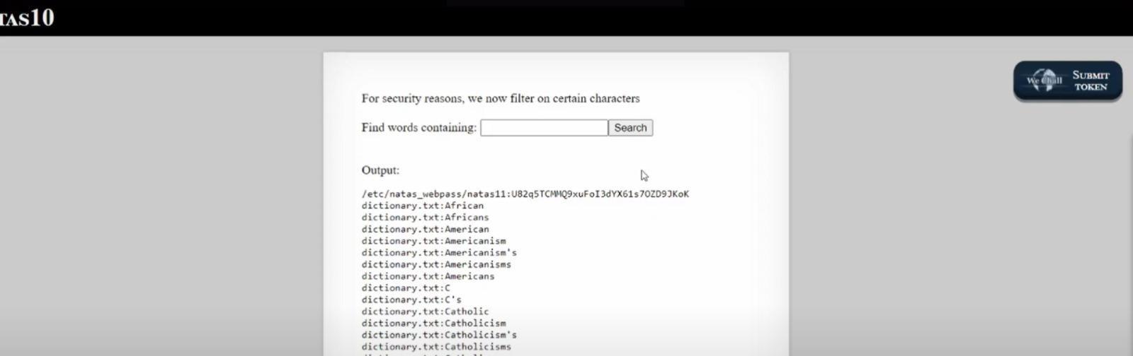

**Level: Natas11**

* **Step-by-Step:**
  + Decrypt cookie value.
  + Change isAdmin from false to true.
  + Re-encrypt cookie.
* **Tools Used:**
  + Terminal (openssl)
* **Logic Behind the Solution:**
  + Encryption understanding and cookie tampering.

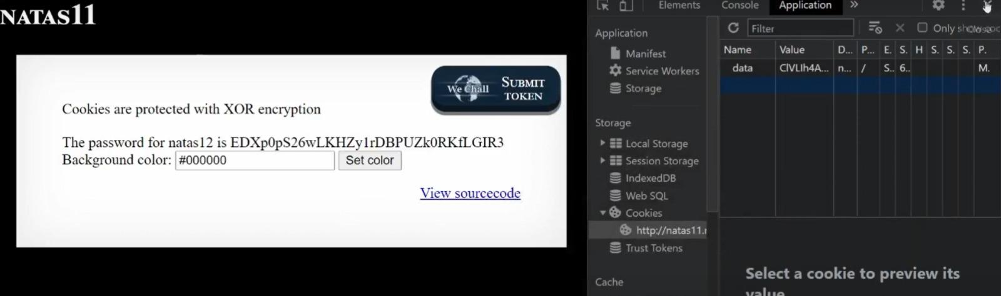

**Level: Natas12**

* **Step-by-Step:**
  + Upload PHP file disguised as an image.
  + Access uploaded PHP file.
* **Tools Used:**
  + Browser, Burp Suite
* **Logic Behind the Solution:**
  + Bypassing file upload restrictions.

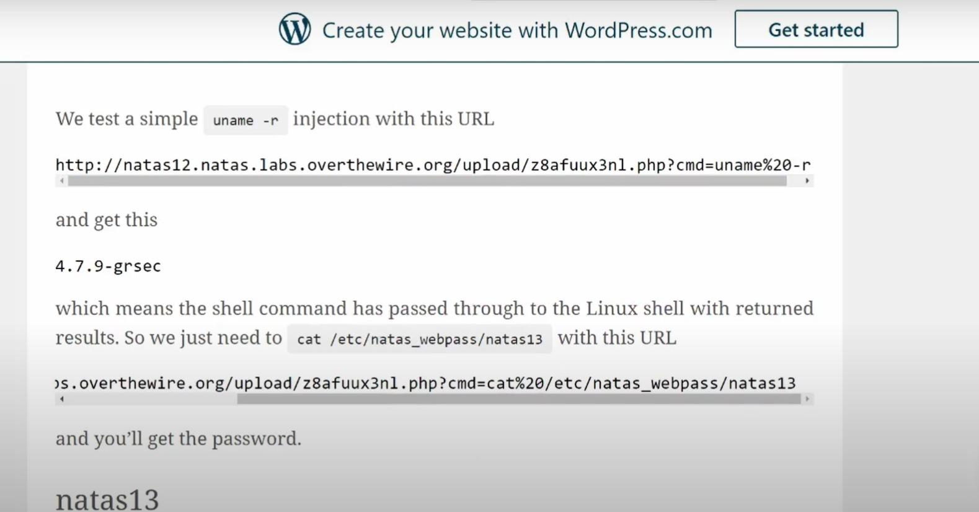

**Level: Natas13**

* **Step-by-Step:**
  + Upload a PHP file directly.
  + Execute uploaded file.
* **Tools Used:**
  + Browser
* **Logic Behind the Solution:**
  + File upload exploitation.



**Level: Natas14**

* **Step-by-Step:**
  + Use SQL Injection in login form:
    - username: "natas15" OR "1"="1"
* **Tools Used:**
  + Browser
* **Logic Behind the Solution:**
  + Classic SQL Injection to bypass login.

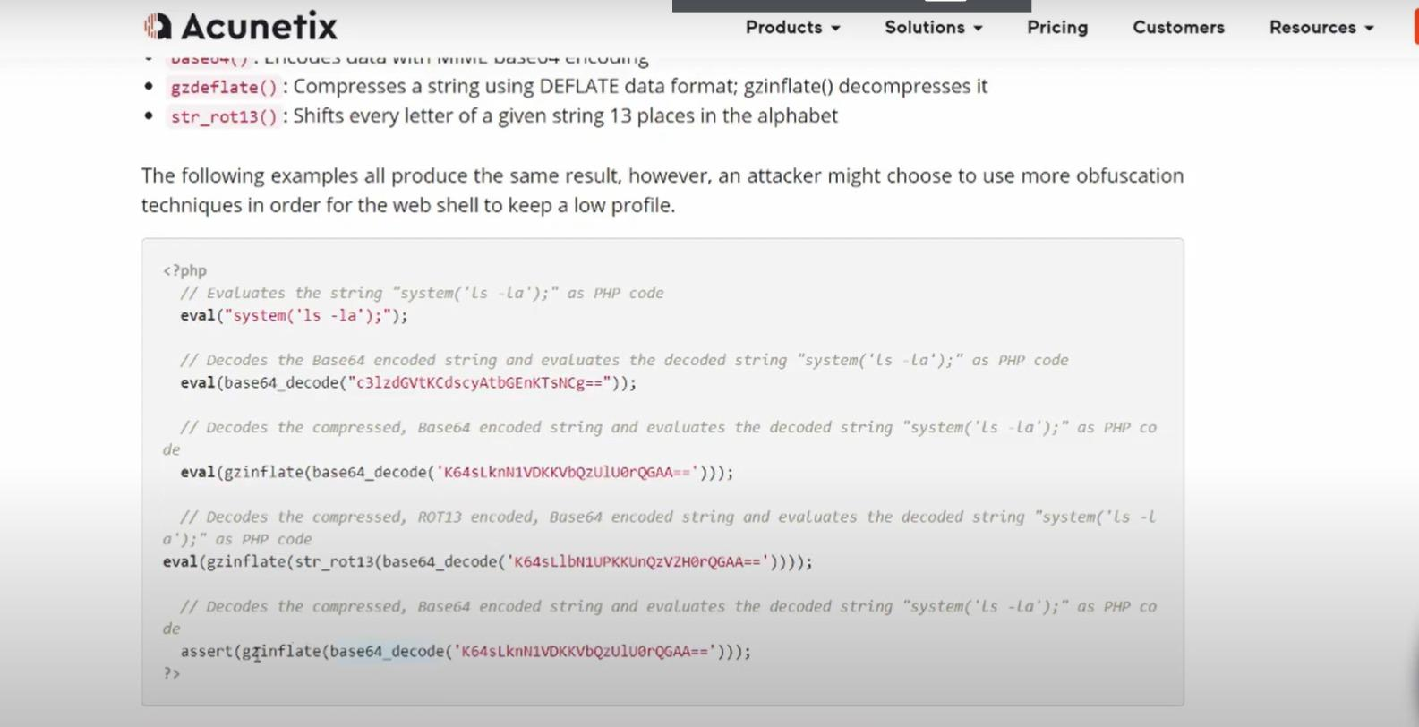

**Level: Natas15**

* **Step-by-Step:**
  + Use Blind SQL Injection guessing each character.
  + Automate using script or Burp Intruder.
* **Tools Used:**
  + Browser, Burp Suite, Script
* **Logic Behind the Solution:**
  + Blind SQL Injection attack using true/false responses.

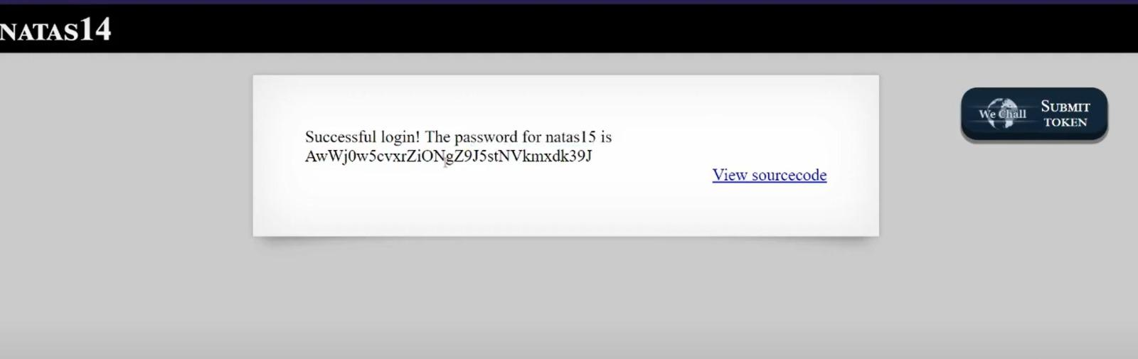

**Level: Natas16**

* **Step-by-Step:**
  + Inject command using | operator.
  + Example: anytext | cat /etc/natas_webpass/natas17
* **Tools Used:**
  + Browser
* **Logic Behind the Solution:**
  + More advanced command injection practice.

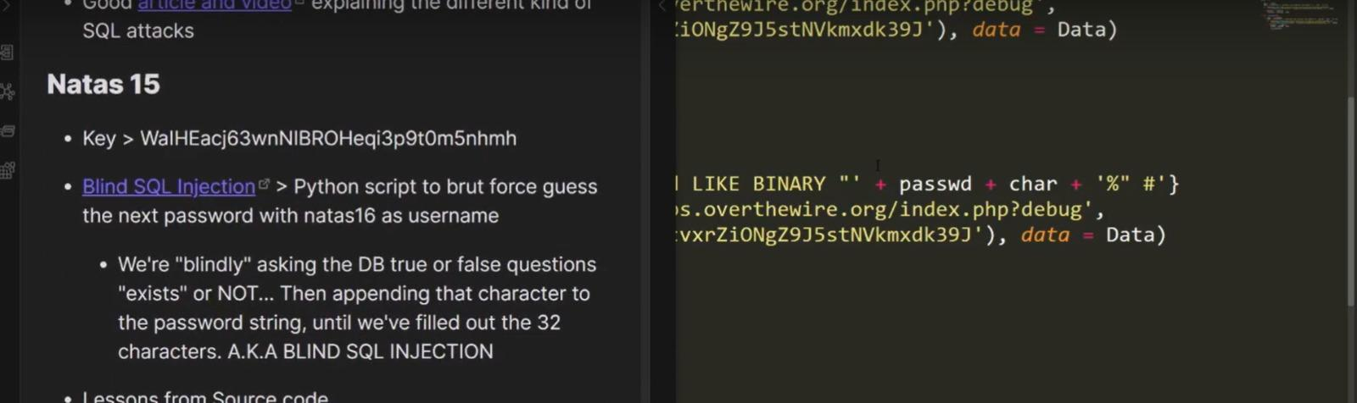

**Level: Natas17**

* **Step-by-Step:**
  + Perform Blind Command Injection.
  + Use time delay like SLEEP(5) to detect true condition.
* **Tools Used:**
  + Browser, Burp Suite
* **Logic Behind the Solution:**
  + Blind injection using response time.

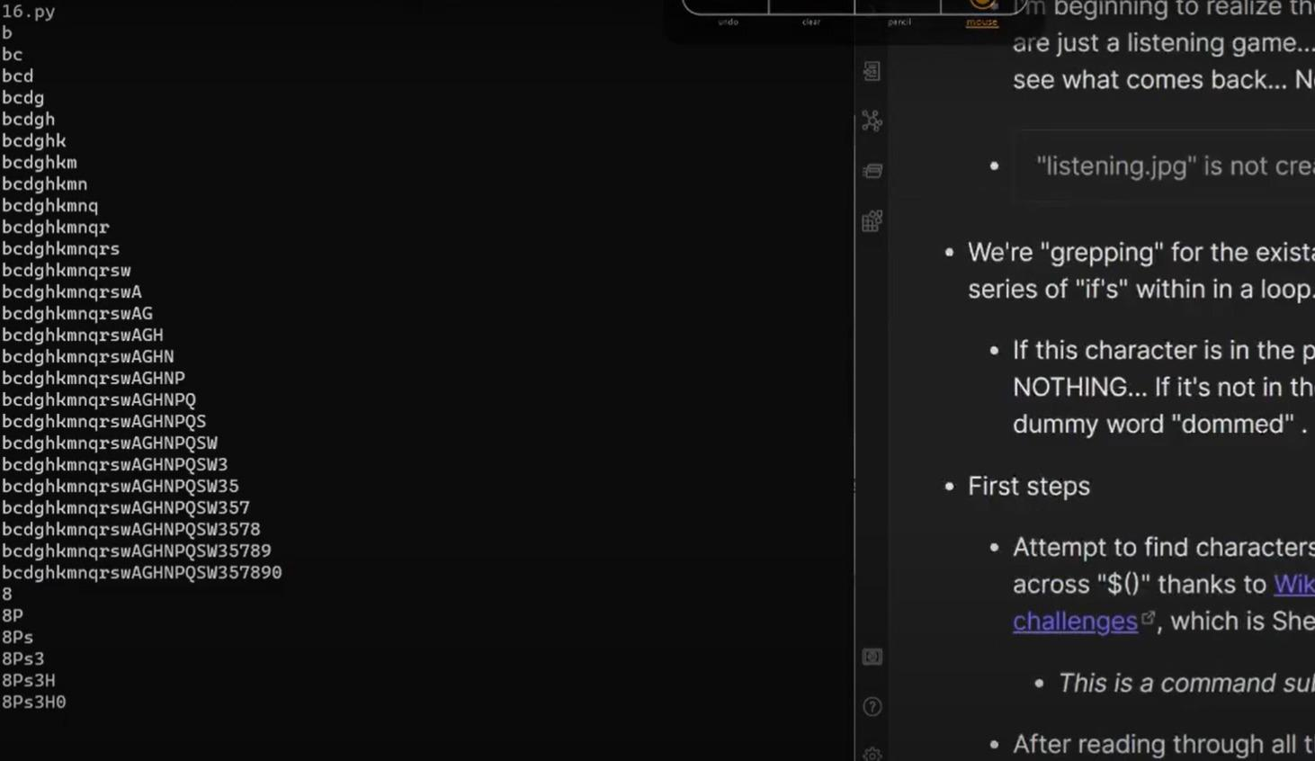

**Level: Natas18**

* **Step-by-Step:**
  + Brute-force session IDs from 1 to 640.
  + Find the session where admin=1.
* **Tools Used:**
  + Browser, bash loop, curl
* **Logic Behind the Solution:**
  + Exploit predictable session IDs.

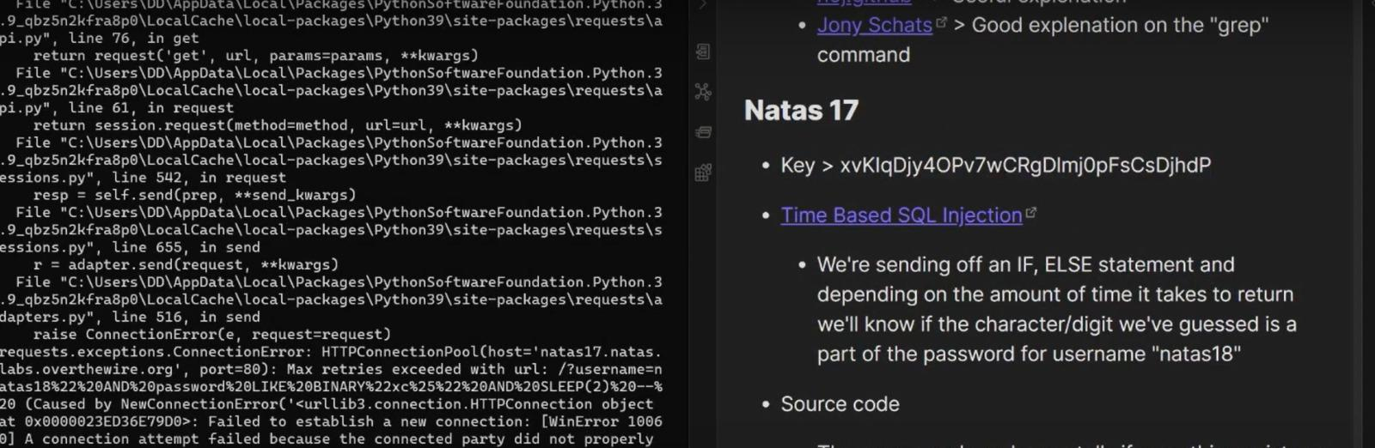

**Level: Natas19**

* **Step-by-Step:**
  + Session ID is encoded in hexadecimal.
  + Brute-force with hex values.
* **Tools Used:**
  + Browser, bash script, curl
* **Logic Behind the Solution:**
  + Find the correct session by decoding hex session IDs.

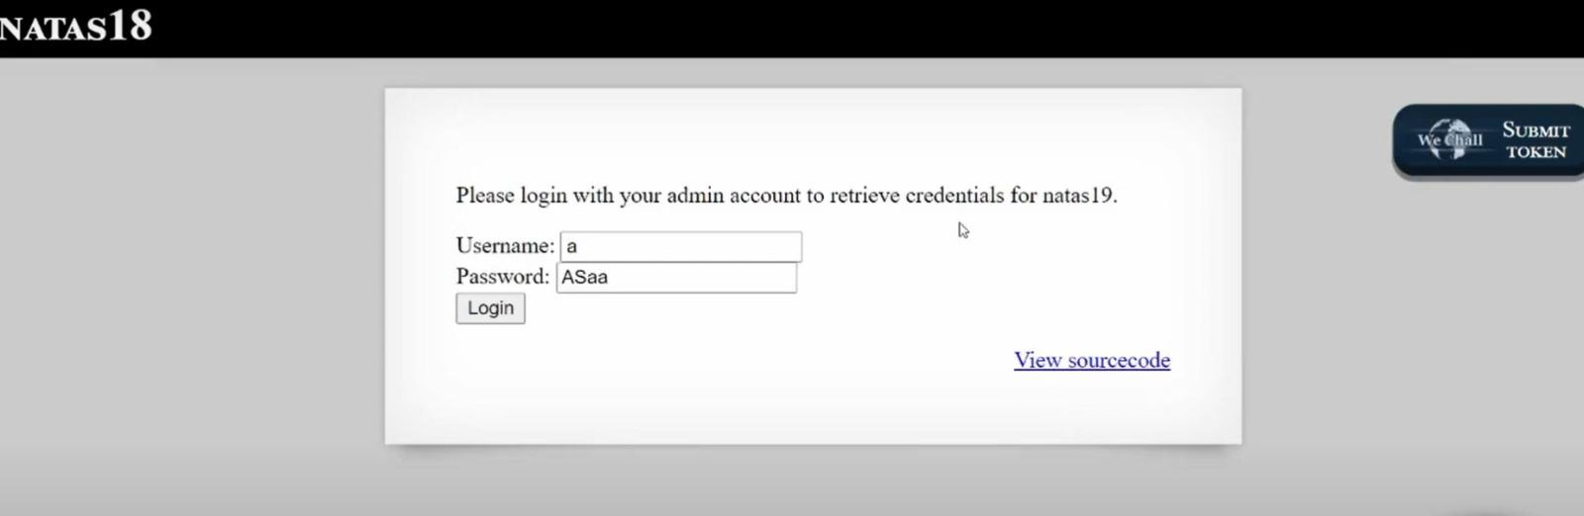

**Level: Natas20**

* **Step-by-Step:**
  + Modify POST parameters to set "debug" to 1.
  + Upload crafted text session manually.
* **Tools Used:**
  + Browser, Burp Suite
* **Logic Behind the Solution:**
  + Session tampering and privilege escalation.

**Level: Natas21**

* **Step-by-Step:**
  + Two different subdomains handle different requests.
  + Modify session to "admin=1" manually.
* **Tools Used:**
  + Browser, Burp Suite
* **Logic Behind the Solution:**
  + Handling multiple sessions across subdomains.

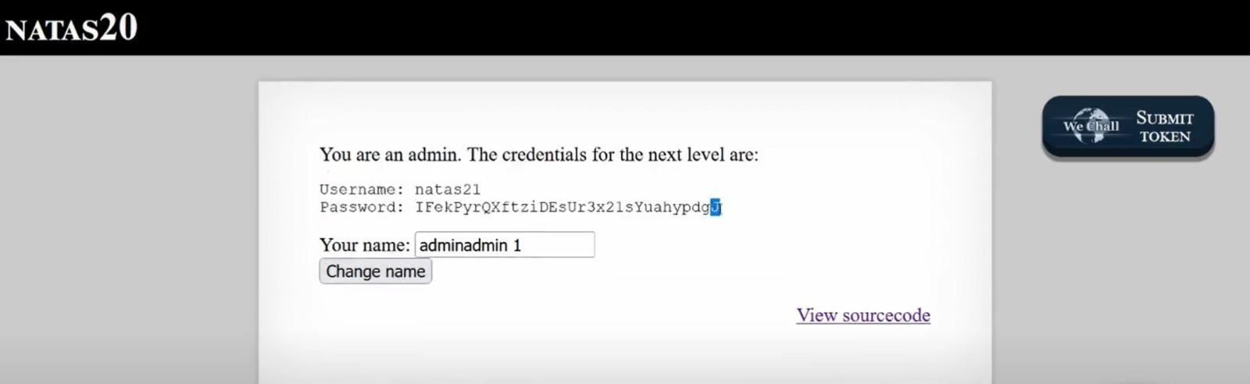

**Level: Natas22**

* **Step-by-Step:**
  + The page redirects instantly.
  + Use curl -i to inspect HTTP headers and get the response before redirection.
* **Tools Used:**
  + curl
* **Logic Behind the Solution:**
  + HTTP redirection behavior exploitation.

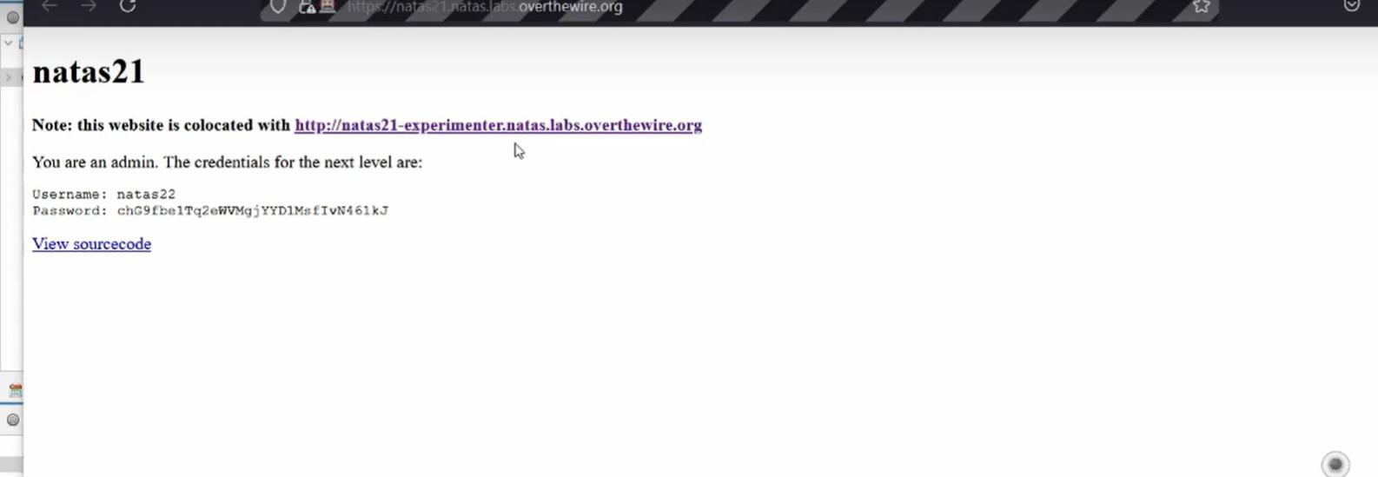

**Level: Natas23**

* **Step-by-Step:**
  + View Page Source.
  + Find the expected secret input.
  + Submit the correct secret.
* **Tools Used:**
  + Browser
* **Logic Behind the Solution:**
  + Simple logic puzzle based on input validation.

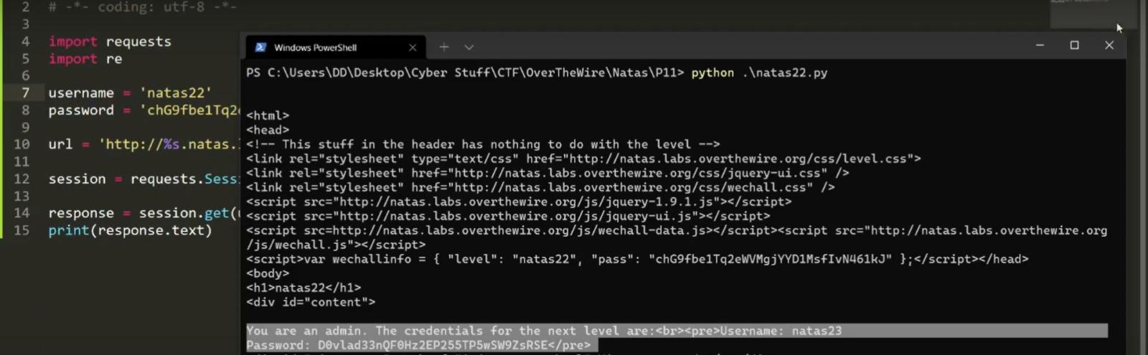

**Level: Natas24**

* **Step-by-Step:**
  + Inject command using POST parameters.
  + Example: "test$(cat /etc/natas_webpass/natas25)"
* **Tools Used:**
  + Browser
* **Logic Behind the Solution:**
  + Exploiting input parsing and command injection.

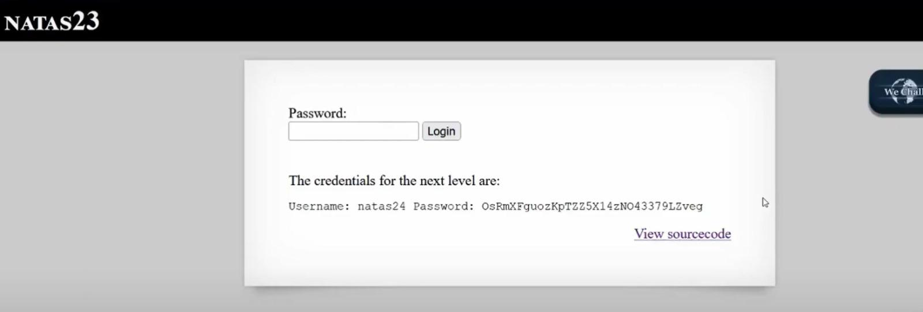

**Level: Natas25**

* **Step-by-Step:**
  + Perform directory traversal in the lang parameter.
  + Try multiple ../ to reach /etc/natas_webpass.
* **Tools Used:**
  + Browser
* **Logic Behind the Solution:**
  + Advanced path traversal attack.

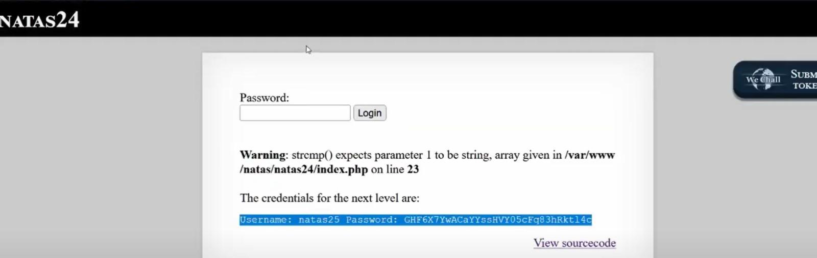

**Level: Natas26**

* **Step-by-Step:**
  + Modify cookie that stores serialized object.
  + Decode, edit, re-encode using base64.
* **Tools Used:**
  + Browser, Python, PHP
* **Logic Behind the Solution:**
  + Object serialization manipulation.

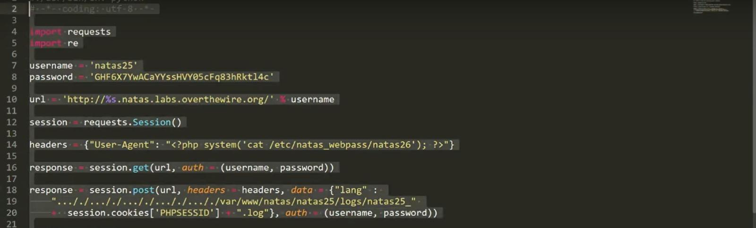

**Level: Natas27**

* **Step-by-Step:**
  + SQL Injection using case sensitivity.
  + Payload: ' UNION SELECT password FROM users WHERE username LIKE BINARY 'natas28' --
* **Tools Used:**
  + Browser
* **Logic Behind the Solution:**
  + Using "BINARY" keyword to perform case-sensitive queries.

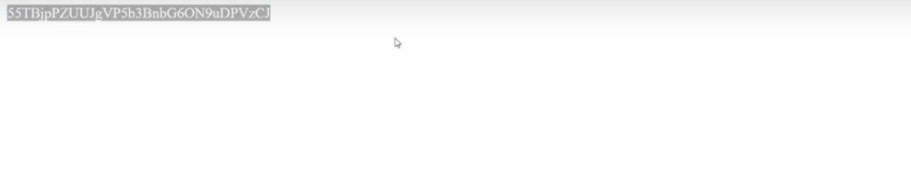

**Level: Natas28**

* **Step-by-Step:**
  + SQL Injection bypassing escaping techniques.
  + Use complicated payloads like ") UNION ALL SELECT password #
* **Tools Used:**
  + Browser
* **Logic Behind the Solution:**
  + Escaping characters properly to break query structure.

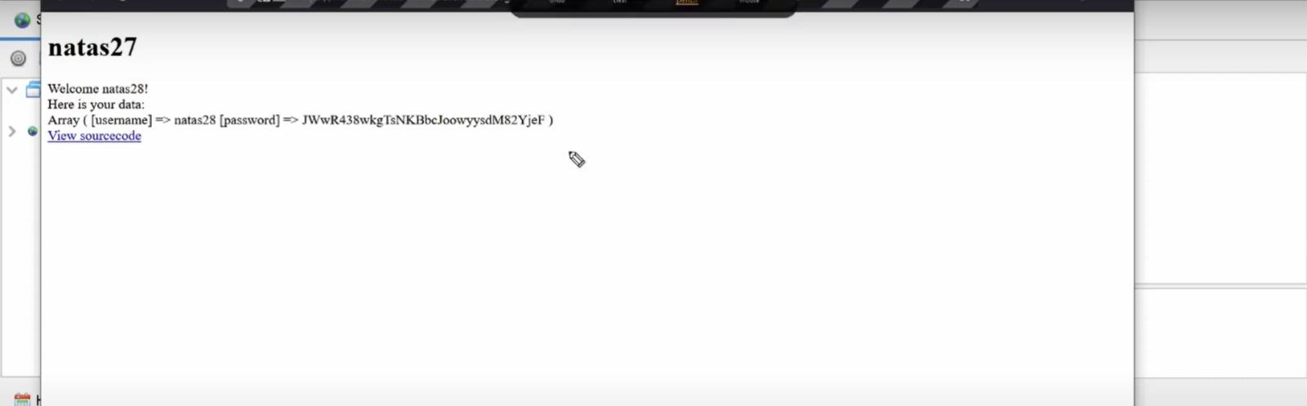

**Level: Natas29**

* **Step-by-Step:**
  + Understand serialized PHP object.
  + Craft malicious serialized object manually.
* **Tools Used:**
  + PHP scripting
* **Logic Behind the Solution:**
  + Abuse serialization to manipulate application behavior.

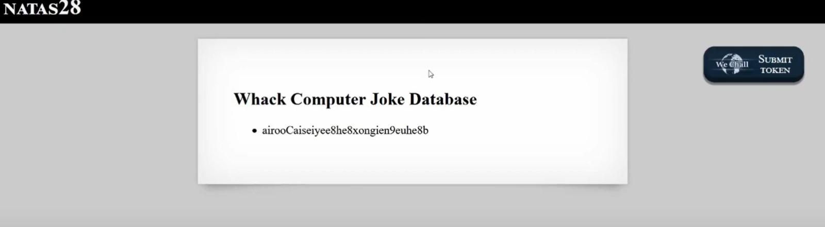

**Level: Natas30**

* **Step-by-Step:**
  + Send multiple parameters with the same name.
  + Example: passwd[]=123&passwd[]=123
* **Tools Used:**
  + Browser, Burp Suite
* **Logic Behind the Solution:**
  + Exploit how PHP processes multiple same-named parameters.

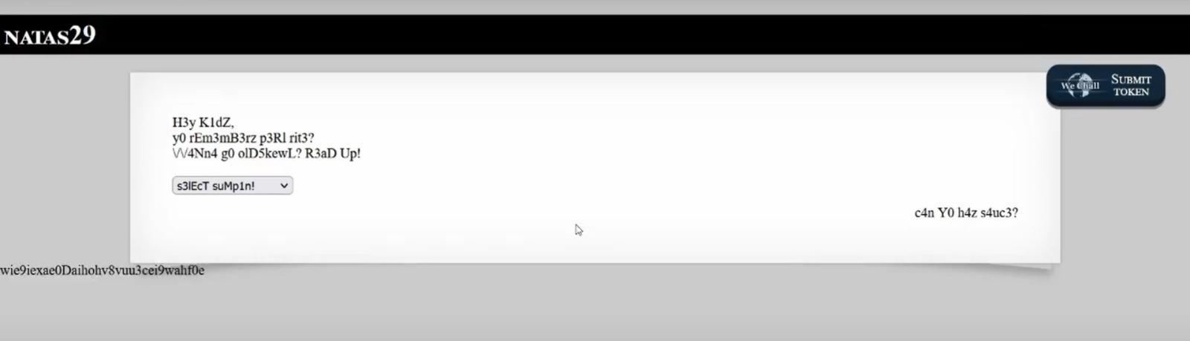

**Level: Natas31**

* **Step-by-Step:**
  + Use multipart/form-data content type.
  + Submit crafted HTTP request via Burp Repeater.
* **Tools Used:**
  + Burp Suite
* **Logic Behind the Solution:**
  + Exploit how web apps parse file uploads differently.

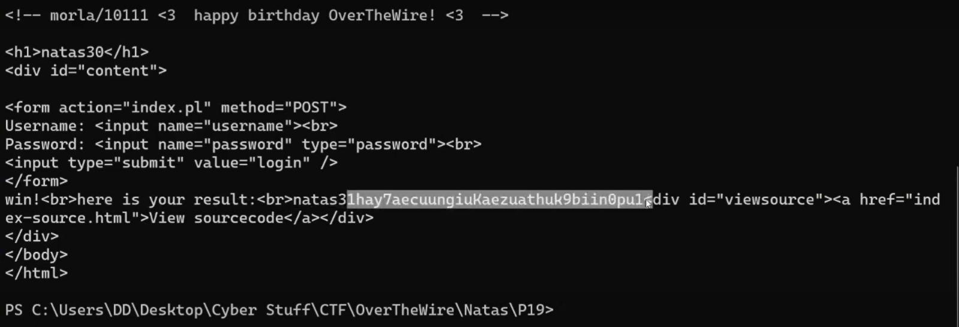

**Level: Natas32**

* **Step-by-Step:**
  + Upload a malicious PHP file.
  + Wait for a cron job to execute it automatically.
* **Tools Used:**
  + Browser
* **Logic Behind the Solution:**
  + Understand webserver and cron job timing attacks.

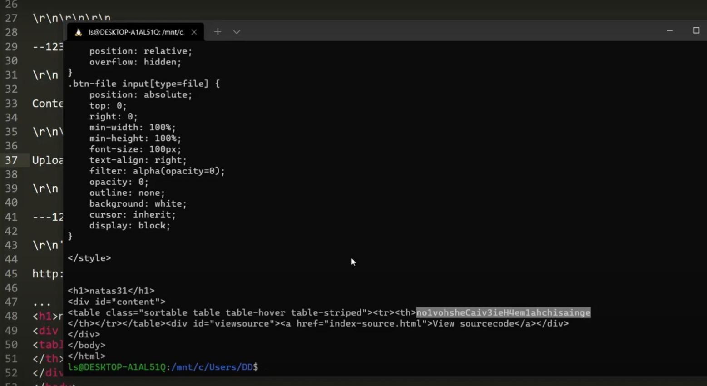

**Level: Natas33**

* **Step-by-Step:**
  + Use SQL Injection.
  + Payload: ' OR 1=1 --
* **Tools Used:**
  + Browser
* **Logic Behind the Solution:**
  + Bypass login forms via always-true SQL queries.

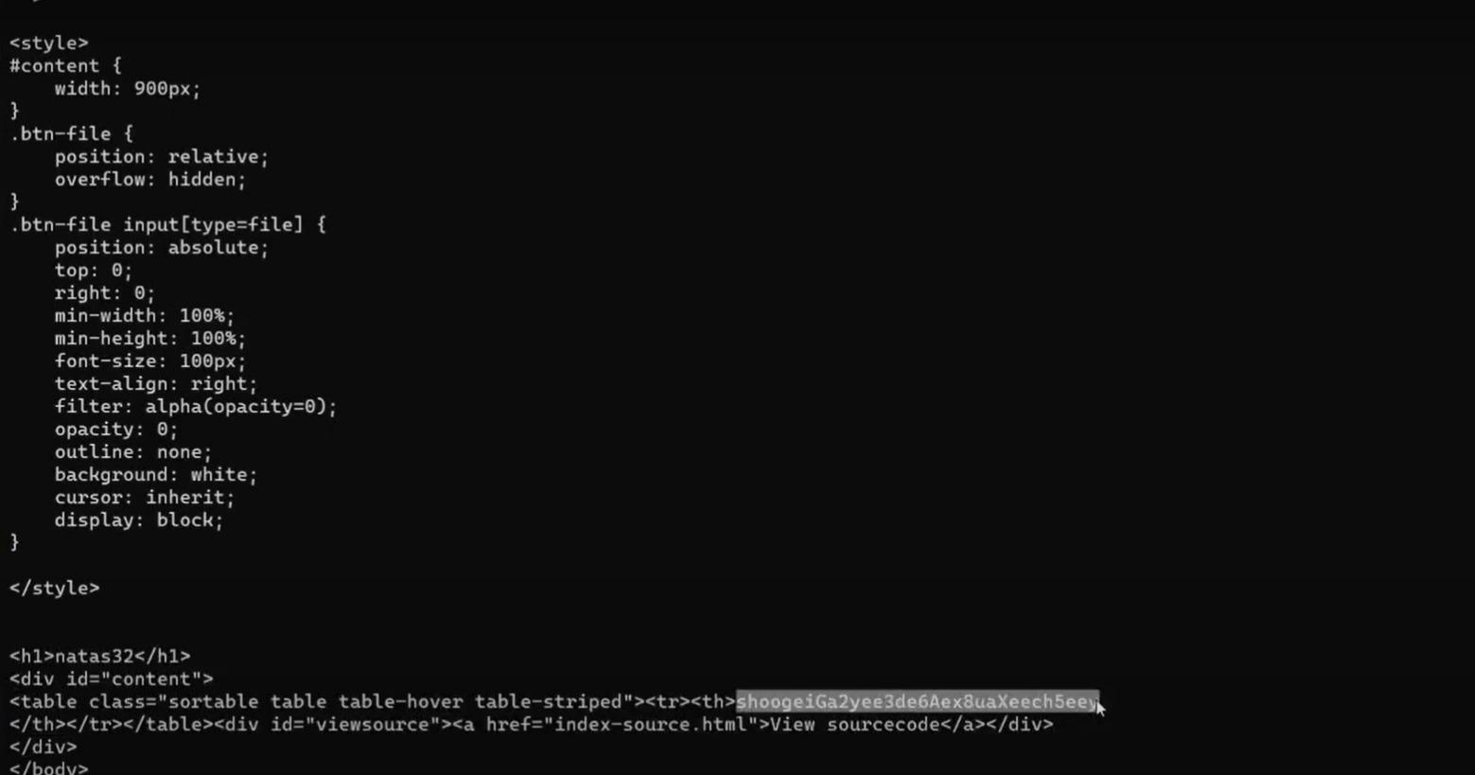

**Level: Natas34**

* **Step-by-Step:**
  + Decode JWT token.
  + Modify the payload (admin:true).
  + Re-sign with known key (or no verification if vulnerable).
* **Tools Used:**
  + jwt.io, Browser
* **Logic Behind the Solution:**
  + JWT forgery and authentication bypass.

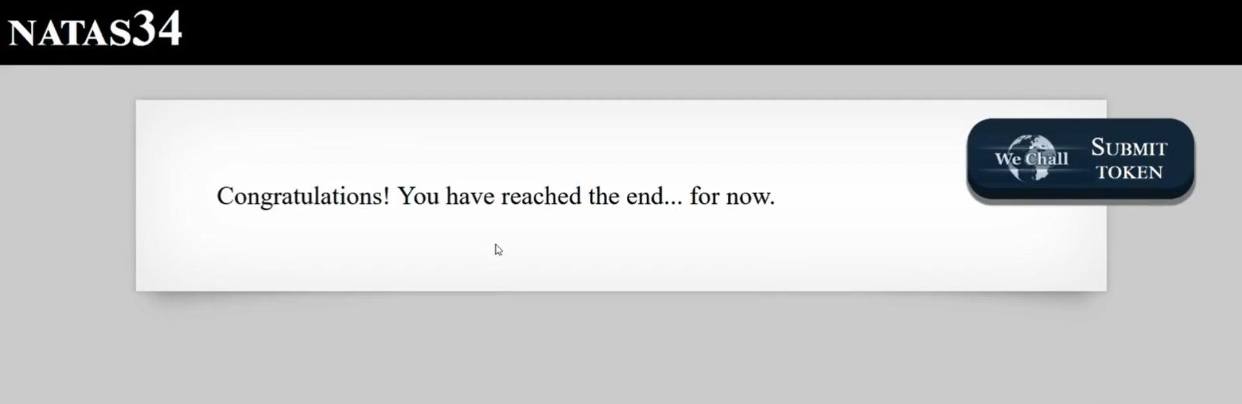

**Tools Commonly Used:**

* Browser (View Source, Inspect, Edit Cookies)
* curl and bash scripts (for brute forcing)
* Burp Suite (for modifying requests)
* Online Tools (jwt.io, base64 decoders)
* Scripting languages (Python, PHP)